Subquery Warmup Worksheet

Remember a subquery contains a query ***nested*** within another query. Parenthesis always go around the inner query.

Subqueries can return 1 or multiple results.

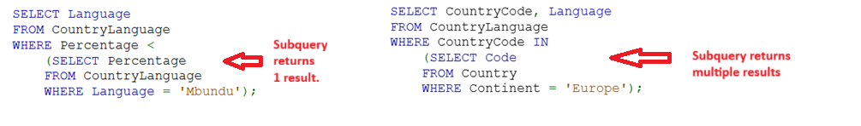

**Warm up: Write a subquery that displays the average price of all red and silver cars.**

